Name : Armaan Tatle | Student ID :N01617608
Date:April 14 2026 | Professor Signature:

Lab 8 – MIPS Architecture Design – CPU Instruction Fetch and Decode

The purpose of this lab is to finish the CPU instruction fetch and decode functions required by the MIPS simulator we built in the last lab.
Procedures
- Download the lab8.zip package from the blackboard.
- Now create a project under C development environment, such as Visual Studio, Netbeans or Eclipse. Please try to avoid using Munro as the limited debug function.
- Hint: Starting from Lab 7, the code will be more and more complicated. As a result, you should consider having a consistent development environment and backup your code more frequently.
- The lab package includes a file called lab8_9.c and a header file lab8header.h. These two files include the major functions you need to finish in this lab, you need to fetch and decode the instructions from memory.
- Add lab8_9.c and lab8header.h to your completed the Lab 7 project (you also need the completed memory.c file from lab 6).
- Add the following statement into the main() function before the end of the “else” closing curly brace.
CPU(mem);
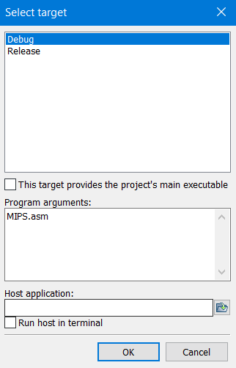
- Similar to lab 7, this program needs to read the assembly code MIPS.asm from hard drive to execute, so please try to add the path to the MIPS assembly language code MIPS.asm as an argument to the run command. Please notice that different IDE would have different settings, you may need to refer to the help document to find this setting. The following screenshot is for Code:Blocks IDE only, you can reach to this screen by going to “Project-> Project Program’s Arguments…”.

- Study the MIPS instruction set definition based on the course materials and lecture notes. Follow the examples your professor gives you during the class time, make sure you understand the 32-bit instruction set structure and how to translate the assembly code into its 32-bit machine code.
- Now try to understand the code, refer to the comments in lab8_9.c and finish the following functions:
unsigned int CPU_fetchCode(char *mem, int codeOffset)
unsigned char CPU_Decode(unsigned int machineCode)
void printRegisterFiles()
void printDataMemoryDump()

Please follow the following submission requirements for this lab:
- This is an individual lab project.
- Must have your own comments to the code.
- Post your screenshots of the output of this lab. Screenshots must have a local computer time/date.
- The lab report (with GH repo link) is due on the blackboard, please check the submission folder on the blackboard.
- Send the GitHub repo link.
- You may be requested to demonstrate Lab 8 in class on April 8.

Screenshots:
